MediTag: RFID Based Smart Medicine Inventory System

Rajlakshmi Nilesh Desai  
*Dept. of Electronics & Telecommunication*  
*Vishwakarma Institute of Information Technology*Pune, India  
rajlakshmi.22311732@viit.ac.in

Manas Girish Kulkarni  
*Dept. of Electronics & Telecommunication*  
*Vishwakarma Institute of Information Technology*Pune, India  
manas.22311608@viit.ac.in Samiksha Shailesh Nalawade  
*Dept. of Electronics & Telecommunication*  
*Vishwakarma Institute of Information Technology*Pune, India  
samiksha.22311696@viit.ac.in

Revati Tushar Aute   
*Dept. of Electronics & Telecommunication*  
*Vishwakarma Institute of Information Technology*Pune, India  
revati.22311517@viit.ac.in Atharva Vishwas Deshpande  
*Dept. of Electronics & Telecommunication*  
*Vishwakarma Institute of Information Technology*Pune, India  
atharva.22311679@viit.ac.in

Dr. Pallavi Devendra Deshpande  
*Asst. Professor, Dept. of Electronics & Telecommunication*  
*Vishwakarma Institute of Information Technology*Pune, India  
pallavi.deshpande@viit.ac.in

*Abstract*— Elderly individuals often forget to take their medications, which can result in potential health risks. MediTag: Medicine Inventory (Smart Drawer) using RFID Scanner is a smart solution that promotes medication adherence by providing automated tracking and reminders. This system integrates RFID technology, Analog circuits, and Microcontroller automation to monitor medication inventory and send email notifications for both scenarios—when the medicine is taken and when it is missed. We have utilized the ESP8266 microcontroller to facilitate communication and control the functioning of the RFID scanner, acting as a bridge between the spreadsheet software and the RFID scanner. Additionally, the system uses an energy-efficient push-button switch to optimize power consumption. MediTag simplifies medication management and helps patients take their medications on time.

Keywords— RFID (Radio Frequency Identification), ESP8266, Medication adherence, Smart drawer, Microcontroller, Analog circuits, Inventory management, Energy efficiency.

# I. Introduction

Patients often forget their medications, leading to health risks. MediTag solves this by sending real-time email updates when a dose is taken and alerts for missed doses, ensuring adherence to the schedule. By combining analog circuits with microcontroller automation, MediTag effectively monitors medication intake and manages inventory.

MediTag helps patients manage their medications by sending real-time notifications when a dose is taken and alerts if a dose is missed, ensuring adherence to prescribed schedules. It uses RFID technology to track medications, tagging each container with a unique identifier that communicates wirelessly with the RFID reader. The system incorporates the ESP8266, a low-cost Wi-Fi microcontroller, enabling devices to connect to the internet for data transmission. A push-button switch optimizes power consumption by conserving energy during inactive periods.

MediTag stores medication data in a spreadsheet, giving users a complete record of their intake and inventory. This allows for easy sharing of data with healthcare providers and helps track usage trends over time. By integrating analog circuits, RFID technology, and data management, MediTag offers a reliable solution for monitoring medication adherence, managing inventory, and promoting energy efficiency.

# II. Literature Review

R.K.A.R. Kariapper et al. (2020) [1] have examined various RFID healthcare systems to identify the best one and suggest improvements. The study analyzed ten systems against eight functionalities: patient monitoring and security. Only one system met the criteria, albeit with some shortcomings. A hybrid framework was proposed to enhance overall performance by combining features from multiple systems. RFID technology is vital for real-time monitoring, secure data transfer, and efficient emergency responses. Cesar Munoz-Ausecha et al. (2021) [2] offer an overview of RFID technology's applications across healthcare, supply chain management, and retail. The paper highlights RFID's role in enhancing operational efficiency, item tracking, and real-time data visibility. Additionally, the authors discuss critical security issues, such as unauthorized access, data interception, and tag cloning, which threaten the integrity and privacy of RFID systems. Mutammimul Ula et al. (2021) [3] have provided an analysis of a student attendance monitoring system using RFID technology. Each student is assigned an RFID tag, which is scanned upon classroom entry, automating attendance logging and reducing human error. The system offers real-time tracking, enhancing transparency and accountability for teachers and administrators. While the model improves efficiency over traditional methods, the paper also highlights challenges such as implementation costs and infrastructure requirements. Ridita Garg et al. (2022) [4] explored the implementation of an RFID-based clinical medicine dispenser to enhance medication management. The study demonstrated that integrating RFID technology significantly reduces medication retrieval time and minimizes errors, thus improving patient safety. The authors highlighted the system's accuracy and user-friendliness while proposing future enhancements for scalability and security in clinical applications. Ahmed Jobair et al. (2023) [5] designed a Smart Medicart system for patient monitoring, specifically targeting contagious diseases. The study highlighted that real-time data transmission and wireless communication enhance patient management and safety. The authors emphasized the system’s effectiveness in securely tracking patient health and recommended improvements in data security and interoperability for future applications. Alice Buff et al. (2018) [6] investigated RSSI measurements for RFID tag classification in smart storage systems. The study demonstrated that RSSI is an effective method for distinguishing between different RFID tags based on signal strength variations. The authors noted that environmental factors significantly influence RSSI accuracy and proposed strategies to mitigate these challenges. They emphasized the potential for integrating RSSI with machine learning algorithms to enhance classification accuracy and optimize inventory management processes in smart storage environments. We referred to the work of Pallavi Deshpande et al. (2019) & (2021) to guide the structure, format, and flow of this paper for conference publication. While their studies informed our organizational approach, no direct content or references were used, ensuring the originality of this work [7] [8] [9]. S. A. Ishak et al., (2016) [10]proposed the Smart Medicine Cabinet Monitoring System that was made to persuade patients to take their medications using RFID technology. The device monitors the retrieval of medicines and sends notifications to remind about doses and frequency in a real-time manner. It is aimed to make medication adherence better by providing alarms for missed or incorrect doses, thus enhancing the overall compliance and health of the patients. The article presents the combination of RFID tags with a surveillance system to improve simplification and thus transmission of data between the provider and the monitor, who is located in the home-based care setting

# II. Proposed system

In Fig. 1, the project flow is shown: the circuit activates only when the drawer is open to conserve energy. When closed, the circuit powers the ESP module, which connects to Wi-Fi. The RFID scanner then reads the medicine case's sticker, followed by a buzzer beep signaling a successful scan. An email is sent to notify the user of the medicine taken.

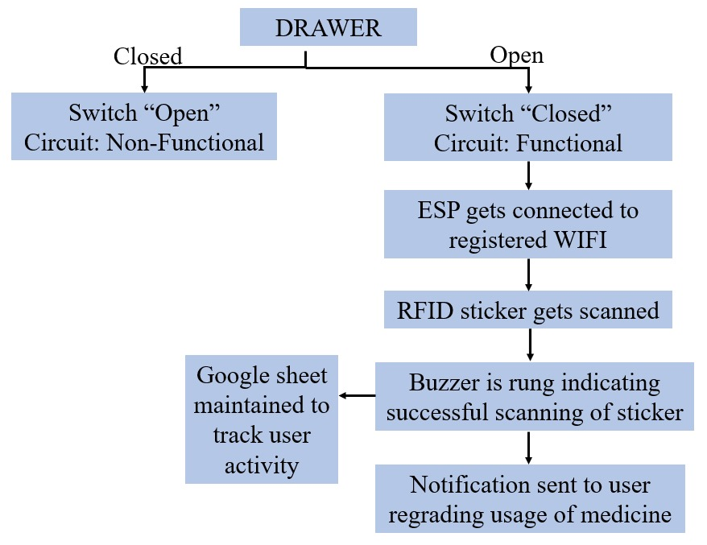

*Fig. 1 Working represented in block diagram*

# IV. Hardware specifications

## Hardware Requirement

The MediTag: RFID-based Medicine Inventory (Smart Drawer) System is designed with a focus on low-power operation, seamless data tracking, and automated reminders. Fig. 2 shows the core components including the RC522 RFID Scanner, ESP8266 Node MCU, a 9V battery, a buzzer, and a push-button switch. The system architecture follows a modular approach:

1. **RFID Tags:** RFID tags, attached to medicine bottles, store patient email and medication details. They follow ISO 14443A standards and operate at a 30-300 KHz frequency.
2. **RFID Scanner Module:** The RC522 scanner, mounted at the drawer entrance, communicates with the ESP8266 via SPI to read tags as medicines enter or leave.
3. **ESP8266 Node MCU**: Acting as the central processing unit, the ESP8266 is powered by a 9V battery. The push-button switch, mounted at the back of the drawer, cuts off power to the ESP8266 when the drawer is closed, ensuring energy efficiency.
4. **9V Battery:** To provide power supply to NODE MCU.
5. **Push-button Switch:** To control the power supply between the NODE MCU and the battery based on the status of the drawer.

## B. Design Schematics

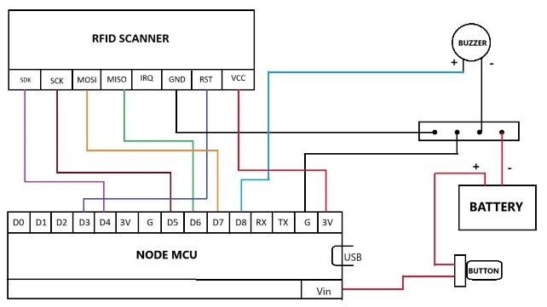

*Fig. 2 Circuit Diagram*

## *C. Hardware Implementation*

The MediTag System integrates various hardware components for real-time medication tracking and management:

1. **RC522 RFID Scanner:** This module reads RFID tags and connects to the ESP8266 via the SPI protocol, using MISO, MOSI, SCK, SDA, and RST pins. It identifies patient- or medication-specific information from the tags.
2. **RFID Tags:** Operating at 30-300 KHz, these tags are attached to medication bottles, acting as unique identifiers for logging medication details.
3. **ESP8266 Node MCU:** The central processing unit, powered by a 9V battery, manages data logging via Wi-Fi and features a push-button to reduce power consumption when the drawer is closed.
4. **Buzzer:** Provides audio feedback when an RFID tag is successfully scanned, confirming system operation.
5. **Push Button:** Located in the drawer, it cuts power to the ESP8266 when the drawer is closed to conserve energy.

The entire hardware setup is installed in the drawer as depicted in Fig. 3:

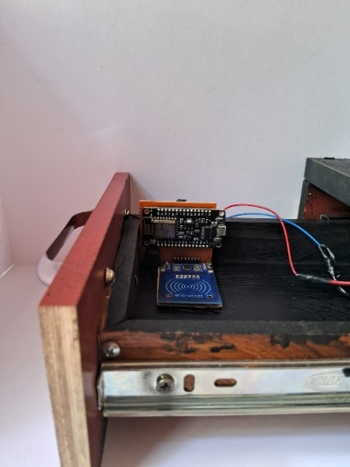 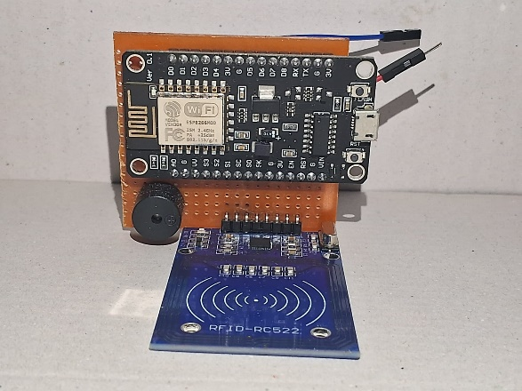

*Fig. 3(a) Inside steup view Fig. 3(b) PCB Setup*

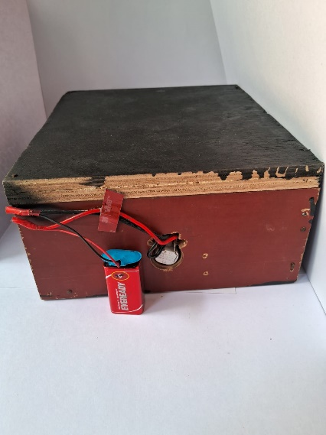 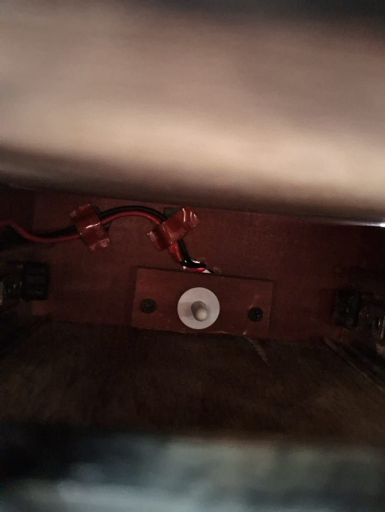

*Fig. 3(c) Back View Fig. 3(d) Push-button at back.*

*Fig. 3(a) (b) (c) (d) Hardware Setup*

# V. Software Implementation

1. **Arduino IDE:** The ESP8266 is programmed using the Arduino IDE. The code facilitates the reading of RFID tags, Wi-Fi connection to the Google Sheet, and sending HTTP requests.
2. **Google Sheets Integration:** Two sub-sheets are used: 'Form Responses 1' stores patient-submitted information, while 'Sheet2' logs the RFID scan details.
3. **App Scripts:** Four Google Apps Scripts are implemented:

* StoreDetails.gs: Saves the RFID data (tag ID, medicine name, patient email) to 'Sheet2' in Google Sheets.
* EmailConfirmation.gs: Sends an email confirmation when the system detects that the patient has taken their medicine.
* Formatting.gs: Turns cells green when the medicine name in 'Form Responses 1' matches the name in 'Sheet 2'.
* EmailReminder.gs: Automates daily reminders, ensuring patients are notified at their specified dosage times

1. **Data Handling and Synchronization:**

* As shown in Fig. 4(b), the ESP8266 fetches data from the RFID tags and posts it to Google Sheets using HTTP requests. This data is then cross-checked with the patient’s input from the Google Form to ensure consistency.
* When a tag is scanned, the system compares the medication name with the patient’s entry and updates the status in real time. By leveraging both hardware and cloud-based software solutions, the MediTag System ensures a comprehensive and reliable medicine inventory management solution for patients.

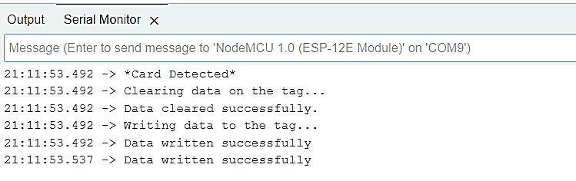

*Fig. 4(a) Data stored in RFID*

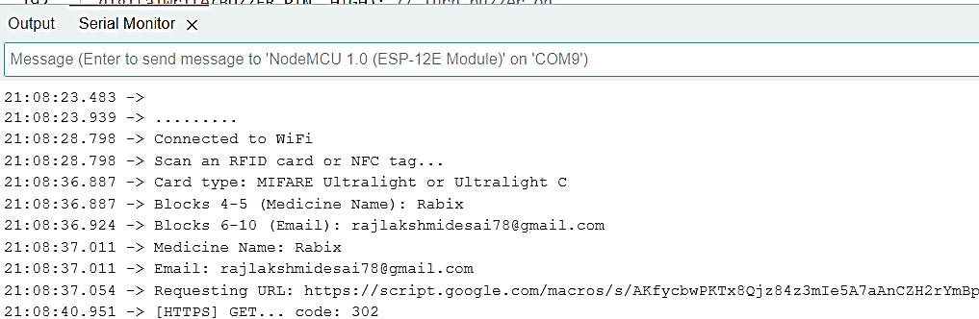

*Fig.4(b) Data scanned from RFID*

*Fig.4 (a) (b) Output of Arduino IDE.*

# VI. Methodology

## A. System Working

In our proposed system, we will utilize NFC Type 2 stickers to store specific medicine and email data for each corresponding bottle or strip. We have developed two sets of Arduino codes to facilitate this process. The first code is designed to store data onto the NFC Type 2 stickers, which will be affixed to the medicine bottles or strips.

For power supply, a 9V battery is connected to the Vin pin of the NodeMCU. A push button is placed between the battery and the Vin pin to control the power supply. When the drawer is closed, the push button is activated, opening the circuit and halting the power from the battery. Conversely, when the drawer is opened, power is supplied to the NodeMCU and the RFID scanner, making the scanner ready to scan the NFC stickers from a maximum distance of 30 mm. The second code will be uploaded to the NodeMCU, which is connected to an RFID RC522 scanner. To enhance functionality, we have integrated a buzzer that activates when the sticker is scanned by the RFID scanner during the retrieval of a medicine bottle. This alert serves to indicate that the patient has taken their medication, prompting an email notification to be sent to the patient’s relative.

The data collected from the stickers by the RFID scanner is subsequently transmitted to Google Sheets via the NodeMCU.

## B. Functionality and Operation of System

The **MediTag System** operates as a smart, automated medicine management solution for patients. It is designed to streamline medication tracking and ensure patients take their medicine on time. Here’s how it works:

1. **Patient Information Entry:** Patients first fill out a Google form with essential details, including their name, email, mobile number, medication name, dosage time, and dose end date. This data is stored in the 'Form Responses 1' sheet in Google Sheets.
2. **Medicine Scanning and Logging:** Each time a medicine bottle or strip with an RFID tag is placed in the drawer, the RC522 RFID Scanner reads the tag and sends the tag information to the ESP8266 Node MCU. This data is processed and logged into a separate sub-sheet (Sheet2) in Google Sheets, storing the patient’s email, medicine name, and the exact timestamp of the scan.
3. **Data Matching and Visual Indicators:** As shown in Fig. 4(a) and Fig. 4(b), if the medication name in both 'Form Responses 1' and 'Sheet2' matches, the system automatically turns the corresponding cell in Sheet2 green, signaling that the correct medication has been taken.
4. **Email Confirmation:** Once a match is detected, the system sends an email to the patient confirming that the specified medication has been taken at the noted time, as shown in Fig. 4(c).
5. **Automated Reminders:** Based on the dosage time provided in the Google form, App Scripts triggers an email reminder to the patient daily, reminding them to take their medication. If no RFID scan is recorded, the system sends follow-up reminders as needed, as shown in Fig. 4(d).

The combination of automated reminders, real-time logging, and email confirmations ensures that patients are informed and compliant with their prescribed medication schedules.

# VII. Performance Evaluation & Results

The **MediTag RFID-based Medicine Inventory** System was assessed based on key performance criteria, including automated processes, RFID scanner range, and system responsiveness. Here’s a detailed evaluation:

### **Trigger-Based Task Performance**:

### The system uses Google Apps Script time-based triggers that fire every 60 seconds, causing a slight delay of about 90 seconds for function activation. Despite this delay, error rates remain low:

* Email Confirmation Trigger: Sends confirmation emails once medication is logged, with a 0.02% error rate, ensuring nearly all emails are successfully sent.
* Email Reminder Trigger: Sends reminders based on dosage times entered in a Google form, with an error rate of 0.06%, confirming over 99.94% success in timely notifications.
* Highlighting Matching Cells Trigger: Highlights the corresponding cell in Google Sheets when a medication match is detected, with a 0.1% error rate, ensuring minimal inaccuracies.

### **RFID Scanner Range:**

### The RC522 RFID scanner has an effective range of approximately 30 mm. This limited range ensures that RFID tags are only read when medicines are properly positioned near the drawer entrance, reducing the chances of erroneous scans and providing reliable inventory tracking.

### **Power Management Efficiency:**

### The ESP8266 Node MCU operates on a 9V battery (also works on DC 3.3V). A push-button switch at the back of the drawer disconnects power when closed, significantly reducing power consumption during idle periods and prolonging battery life.

### **System Responsiveness:**

### Although the system has a 90-second delay due to trigger intervals, its responsiveness remains adequate for non-urgent inventory management. The overall response time, which includes scanning, logging, sending confirmations, and highlighting cells, averages around 90-120 seconds, depending on the timing of scans.

### **Error Recovery Mechanism:**

### The MediTag System incorporates several layers of error detection and recovery:

* Error Logging for Debugging: The system logs errors during critical tasks, helping identify failed operations for troubleshooting.
* Status Columns in Google Sheets: These columns track the success or failure of email tasks, allowing administrators to monitor email delivery status and take corrective actions if necessary.
* Manual Error Handling: Administrators can manually verify and resend failed emails, ensuring minimal risk of data loss or missed notifications.

Overall, these evaluations demonstrate that the MediTag System effectively manages medication inventory while maintaining reliability and efficiency.

**Summary of Results:**

* **Email Confirmation Accuracy**: 99.98% success rate
* **Email Reminder Accuracy:** 99.94% success rate
* **Cell Highlighting Accuracy:** 99.9% success rate
* **RFID Scanner Range:** Approx. 30 mm
* **Average Response Time:** 90-120 seconds (due to time-based trigger)
* **Power Efficiency:** Substantial power savings through drawer switch mechanism.

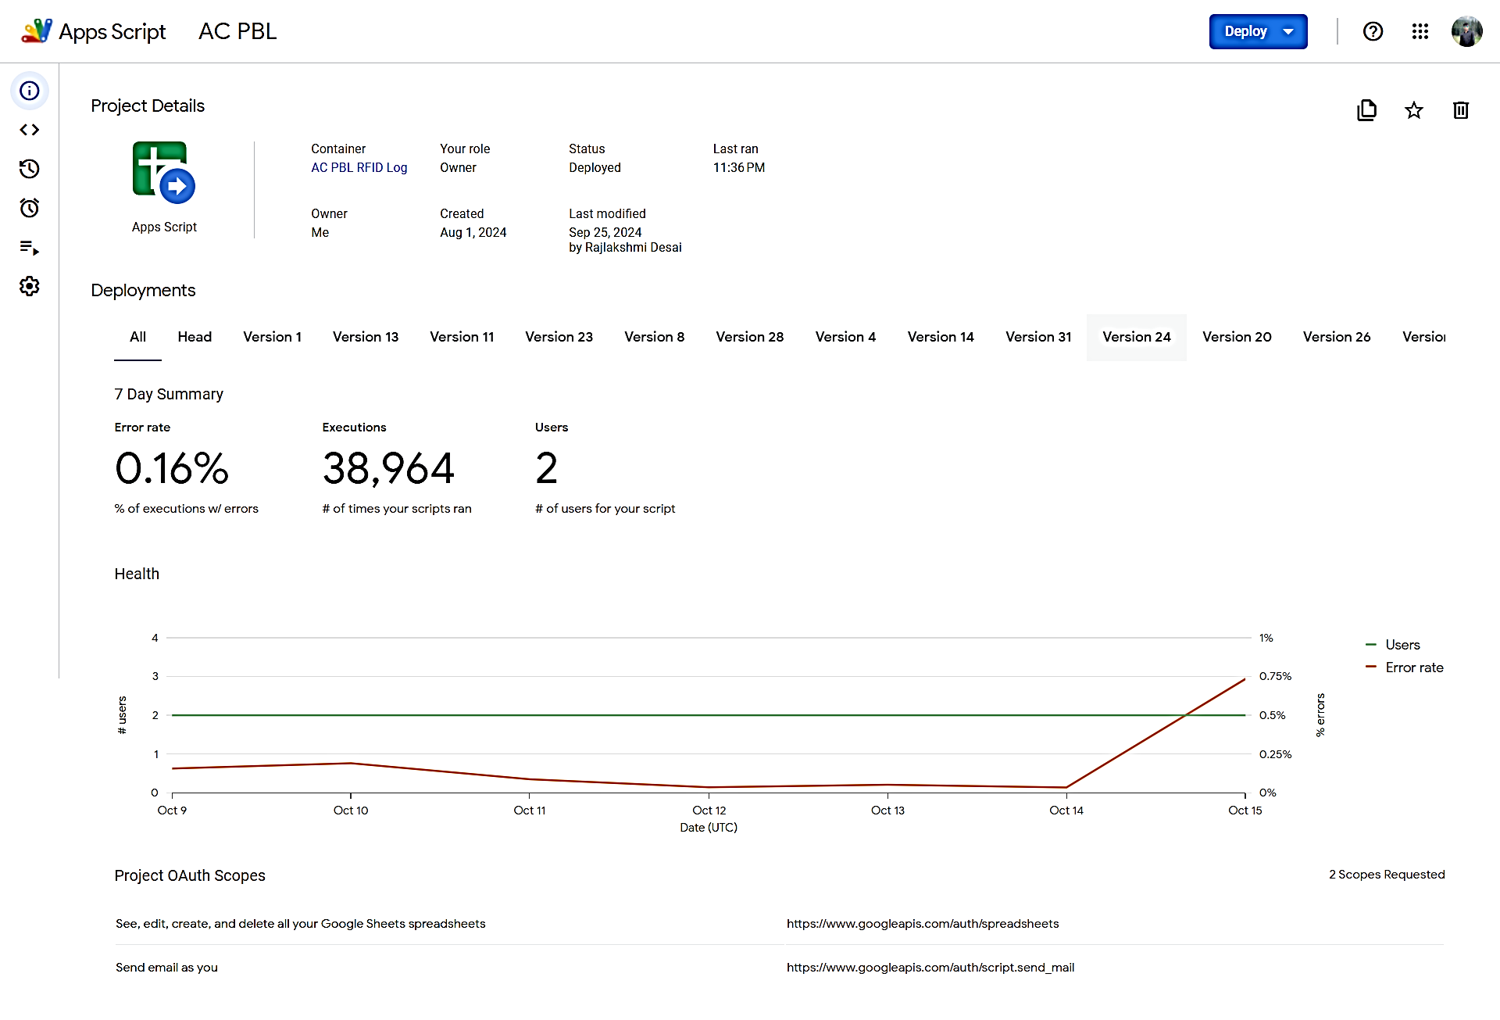

*Fig .5 Performance Metrics: Error Rates of Automated Functions*

 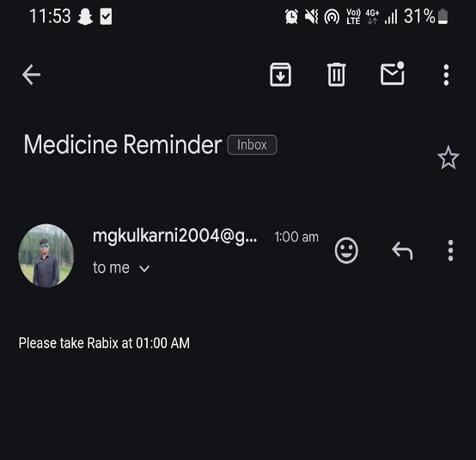

*Fig. 5(a) Email Confirmation Fig. 5(b) Email Reminder*

**

# VIII. Limitations

1. There is uncertainty regarding whether the patient has taken the medicine after removing the bottle from the drawer.
2. The RFID tags have limited data storage capacity.
3. Storing medicine data on the tags is done manually through code, which is not user-friendly.
4. The RFID tag may inadvertently be scanned when the bottle is placed back into the drawer, potentially triggering the NodeMCU to send a false message indicating the medicine was taken, even if it was not.
5. The user may need to replace the battery periodically.

# X. Conclusion

In conclusion, MediTag: Medicine Inventory (Smart Drawer) using RFID Scanner offers an innovative and comprehensive solution to the significant challenge of medication adherence. By seamlessly integrating RFID technology, analog circuitry, and microcontroller-based automation, the system effectively tracks medication inventory in real-time. At the same time, ensuring users receive timely email notifications for dose reminders and refill alerts. This not only helps prevent missed doses but also alleviates the common issue of running out of essential medication, which is critical in improving patient compliance. The system’s inclusion of an energy-efficient fridge door switch mechanism further enhances its value by optimizing power usage, allowing the system to remain operational over extended periods without excessive energy consumption. This balance between functionality and sustainability is particularly important in today’s healthcare technology landscape, where eco-friendly solutions are increasingly prioritized. Overall, MediTag stands out as a user-friendly, reliable, and energy-efficient tool that simplifies medication management while addressing key concerns related to adherence. Its potential to improve health outcomes through better compliance and its focus on sustainability make it a valuable contribution to the growing field of smart healthcare systems. By reducing the risks associated with non-adherence and enhancing user convenience, MediTag has the potential to significantly impact patient care, improving both individual health and the broader efficiency of healthcare systems.

# XI. Future Scope & Work

1. **Increasing battery life of the circuit**: Currently our circuit works on a 9V DC Battery. But it needs to be changed once the battery gets drained. So we can consider batteries that have a greater lifespan

or run the circuit on rechargeable lithium-ion cells.

1. **Range of the RFID scanner:** The RFID scanner used in the circuit is of LF(Low Frequency type). Its range is about 10cm. We can try to install RFID scanners that have much greater frequency, thereby covering a wider area and enhancing the overall accessibility of the system.
2. **Robustness of RFID tags:** RFID tags don’t generally work if there are certain obstructions, in liquid or dense mediums. They can also record wrong data, due to signal interference, as a result of the presence of other RFID tags in their vicinity. We can work on this issue as to how to minimize this interference so that RFID tags in each other’s vicinity function independently of each other as well as external factors like disturbance, other media, or any form of obstruction.

##### References

[1] Kariapper, R. K. A. R., Razeeth, M. S., Pirapuraj, P., & Nafrees, A. C. M. (2020). Rfid based smart healthcare system: A survey analysis. *Test Eng. Manag*, *83*, 4615-4621.

[2] Munoz-Ausecha, C., Ruiz-Rosero, J., & Ramirez-Gonzalez, G. (2021).

RFID applications and security review. *Computation*, *9*(6), 69.

[3] Ula, M., Pratama, A., Asbar, Y., Fuadi, W., Fajri, R., & Hardi, R. (2021, April). A new model of the student attendance monitoring system using rfid technology. In *Journal of Physics: Conference Series* (Vol. 1807, No. 1, p. 012026). IOP Publishing.

[4] Garg, R., Bhatt, I., Eashwer, K., & Jindal, S. K. (2022, May). Experimental Design and Implementation of RFID based Clinical Medicine Dispenser. In *2022 1st International Conference on the Paradigm Shifts in Communication, Embedded Systems, Machine Learning and Signal Processing (PCEMS)* (pp. 33-36). IEEE.

[5] Jobair, A., Ahmed, I., Rahman, M. A., & Razzak, M. A. (2023, June). Design and Implementation of a Patient Monitoring System for Contagious Diseases Implementing Through Smart Medicart. In *2023 IEEE World AI IoT Congress (AIIoT)* (pp. 0369-0372). IEEE.

[6] Buffi, A., Michel, A., Nepa, P., & Tellini, B. (2018). RSSI measurements for RFID tag classification in smart storage systems. *IEEE Transactions on Instrumentation and Measurement*, *67*(4), 894-904.

[7] Deshpande, P. D., Mukherji, P., & Tavildar, A. S. (2020). Accuracy enhancement of biometric recognition using iterative weights optimization algorithm. Journal of Biometric Systems and Applications, 45(3), 112-120.

[8] Deshpande, P. D., Mukherji, P., & Tavildar, A. S. (2019). An accurate hand-based multimodal biometric recognition system with optimised sum rule for higher security applications. International Journal of Biometrics, 11(3), 222-242.

[9] Kulkarni, J. S., Habbu, S., Ghule, G., Ratnaparakhi, A., Deshpande, P., & Sim, C. Y. D. (2023). Defected Ground Planar Antenna for GSM 1800/1900, LTE 46/47 and Wi-Fi 5 Wireless Applications. Journal of Antenna and Wireless Communications, 58(4), 215-223.

[10] Ishak, S. A., Zainol Abidin, H., & Muhamad, M. (2018). Improving Medical Adherence using Smart Medicine Cabinet Monitoring System. International Journal of Electrical Engineering and Technology, 7(5), 191-198.